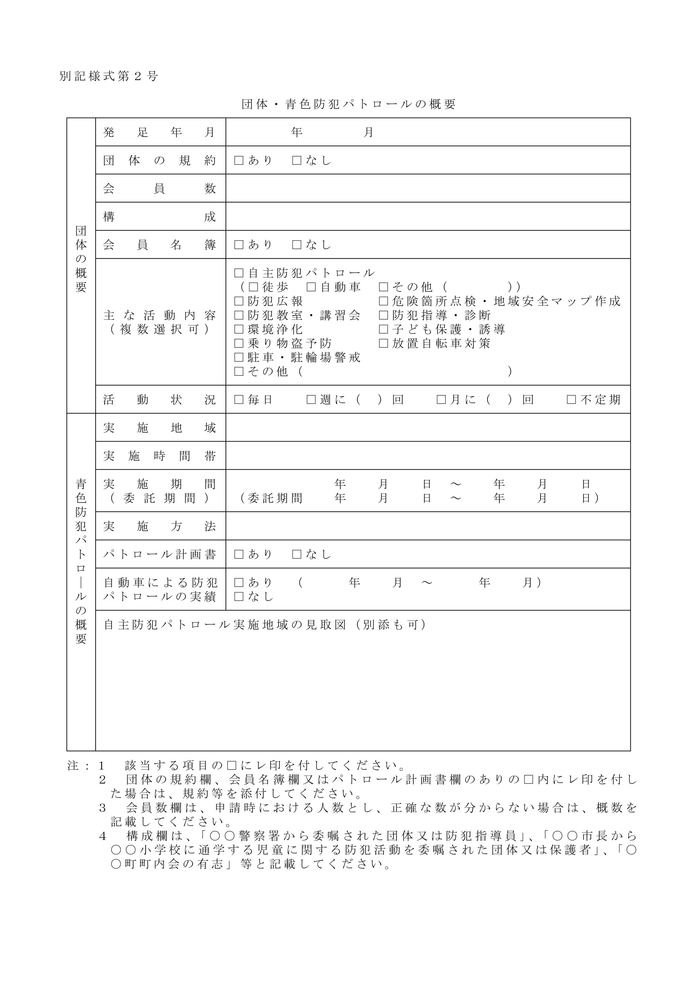

✓

✓

✓

✓

✓

✓

✓

✓

✓

✓

✓

✓

✓

✓

✓

別添のとおり